COMSATS University Islamabad

Attock Campus



MAD

AHMED IKRAM RAO

(sp22-bse-049)

24 DEC, 2024

APP.js
import React from 'react';
import { NavigationContainer } from '@react-navigation/native';
import { createStackNavigator } from '@react-navigation/stack';
import { Provider } from 'react-redux';
import store from './store';
import SignupScreen from './screens/SignupScreen';
import LoginScreen from './screens/LoginScreen';
import ThirdScreen from './screens/ThirdScreen';

const Stack = createStackNavigator();

export default function App() {
return (
<Provider store={store}>
<NavigationContainer>
<Stack.Navigator initialRouteName="Signup">
<Stack.Screen name="Signup" component={SignupScreen} />
<Stack.Screen name="Login" component={LoginScreen} />
<Stack.Screen name="ThirdScreen" component={ThirdScreen} />
</Stack.Navigator>
</NavigationContainer>
</Provider>
);
}

Firebaseconfig.js
import { initializeApp } from 'firebase/app';
import { getAuth } from 'firebase/auth';

const firebaseConfig = {
apiKey: "AIzaSyD-FirebaseAPIKeyHere",
authDomain: "madprojecttt-f39c9.firebaseapp.com",
projectId: "madprojecttt-f39c9",
storageBucket: "madprojecttt-f39c9.appspot.com",
messagingSenderId: "123456789012",
appId: "1:123456789012:web:abc123def456ghijk789lmn",
};

const app = initializeApp(firebaseConfig);
export const auth = getAuth(app);

userslice.js
import { createSlice } from '@reduxjs/toolkit';

const initialState = {
username: '',
email: '',
password: '',
phone: '',
location: '',
};

const userSlice = createSlice({
name: 'user',
initialState,
reducers: {
setUserDetails: (state, action) => {
return { ...state, ...action.payload };
},
setLocation: (state, action) => {
state.location = action.payload;
},
},
});

export const { setUserDetails, setLocation } = userSlice.actions;
export default userSlice.reducer;

Store.js
import { configureStore } from '@reduxjs/toolkit';
import userReducer from './slices/userSlice';

const store = configureStore({
reducer: {
user: userReducer,
},
});

export default store;

Signuup
import React from 'react';
import { useDispatch } from 'react-redux';
import { setUserDetails } from '../slices/userSlice';
import { createUserWithEmailAndPassword } from 'firebase/auth';
import { auth } from './firebaseConfig';
import { View, TextInput, Button, Text, StyleSheet } from 'react-native';

export default function SignupScreen({ navigation }) {
const dispatch = useDispatch();
const [username, setUsername] = React.useState('');
const [email, setEmail] = React.useState('');
const [password, setPassword] = React.useState('');
const [phone, setPhone] = React.useState('');

const handleSignup = async () => {
try {
const emailRegex = /^[^\s@]+@[^\s@]+\.[^\s@]+$/;
const phoneRegex = /^\+92-3\d{2}-\d{7}$/;

if (!username.match(/^[A-Za-z]+$/)) return alert('Username must contain alphabets only.');
if (!emailRegex.test(email)) return alert('Invalid email format.');
if (password.length < 8) return alert('Password must be at least 8 characters.');
if (!phoneRegex.test(phone)) return alert('Phone number must match +92-3xx-xxxxxxx format.');

await createUserWithEmailAndPassword(auth, email, password);
dispatch(setUserDetails({ username, email, password, phone }));
navigation.navigate('Login');
} catch (error) {
alert(error.message);
}
};

return (
<View style={styles.container}>
<Text>Signup</Text>
<TextInput placeholder="Username" value={username} onChangeText={setUsername} style={styles.input} />
<TextInput placeholder="Email" value={email} onChangeText={setEmail} style={styles.input} />
<TextInput placeholder="Password" value={password} onChangeText={setPassword} style={styles.input} secureTextEntry />
<TextInput placeholder="Phone" value={phone} onChangeText={setPhone} style={styles.input} />
<Button title="Signup" onPress={handleSignup} />
</View>
);
}

const styles = StyleSheet.create({
container: { flex: 1, justifyContent: 'center', padding: 20 },
input: { borderWidth: 1, padding: 10, marginVertical: 10 },
});
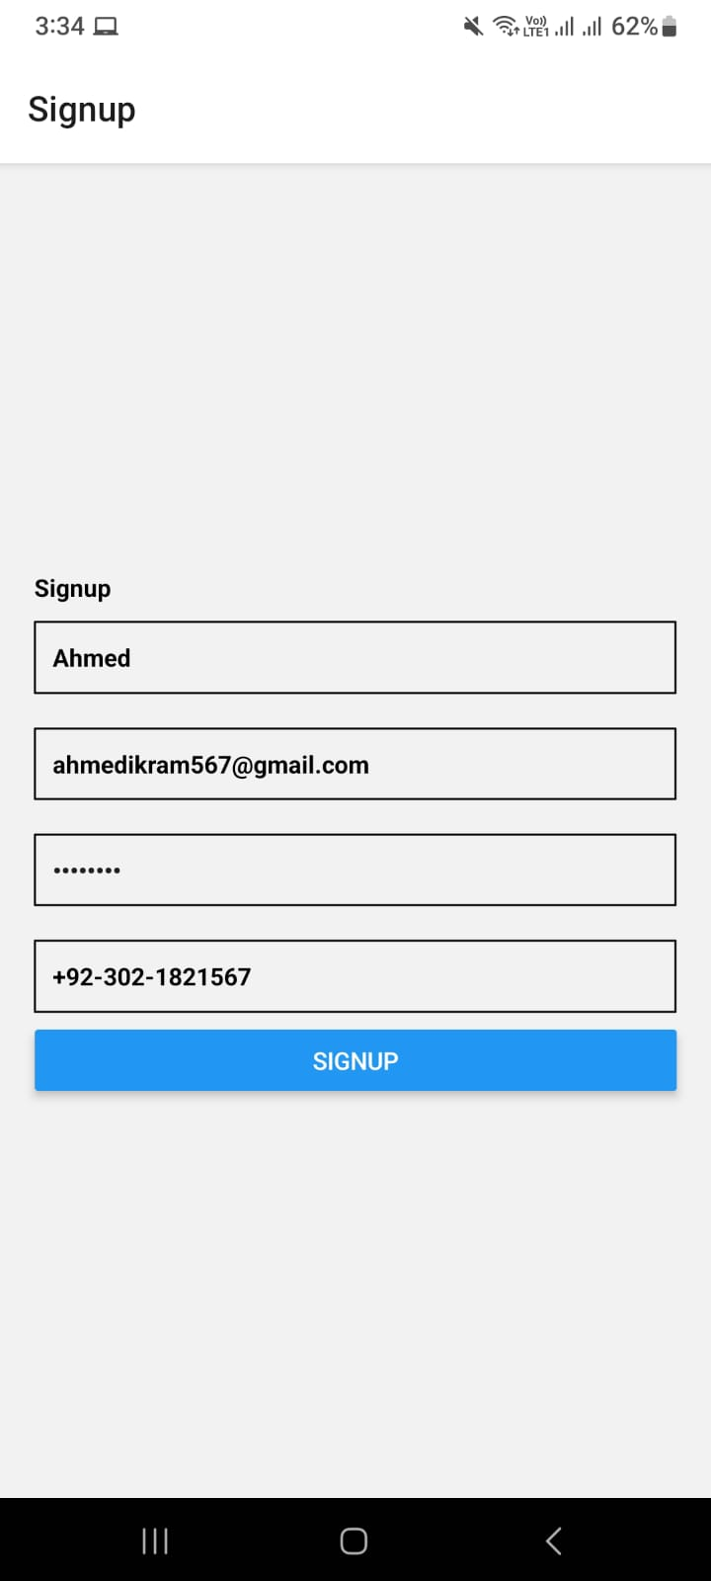
Login.js
import React from 'react';
import { signInWithEmailAndPassword } from 'firebase/auth';
import { auth } from './firebaseConfig';
import * as Location from 'expo-location';
import AsyncStorage from '@react-native-async-storage/async-storage';
import { useDispatch } from 'react-redux';
import { setLocation } from '../slices/userSlice';
import { View, TextInput, Button, Text, StyleSheet } from 'react-native';

export default function LoginScreen({ navigation }) {
const dispatch = useDispatch();
const [email, setEmail] = React.useState('');
const [password, setPassword] = React.useState('');

const fetchLocation = async () => {
const { status } = await Location.requestForegroundPermissionsAsync();
if (status !== 'granted') {
alert('Permission to access location was denied');
return null;
}
return await Location.getCurrentPositionAsync({});
};

const handleLogin = async () => {
try {
await signInWithEmailAndPassword(auth, email, password);
const location = await fetchLocation();
if (location) {
dispatch(setLocation(location));
await AsyncStorage.setItem('userLocation', JSON.stringify(location));
}
navigation.navigate('ThirdScreen');
} catch (error) {
alert(error.message);
}
};

return (
<View style={styles.container}>
<Text>Login</Text>
<TextInput placeholder="Email" value={email} onChangeText={setEmail} style={styles.input} />
<TextInput placeholder="Password" value={password} onChangeText={setPassword} style={styles.input} secureTextEntry />
<Button title="Login" onPress={handleLogin} />
</View>
);
}

const styles = StyleSheet.create({
container: { flex: 1, justifyContent: 'center', padding: 20 },
input: { borderWidth: 1, padding: 10, marginVertical: 10 },
});

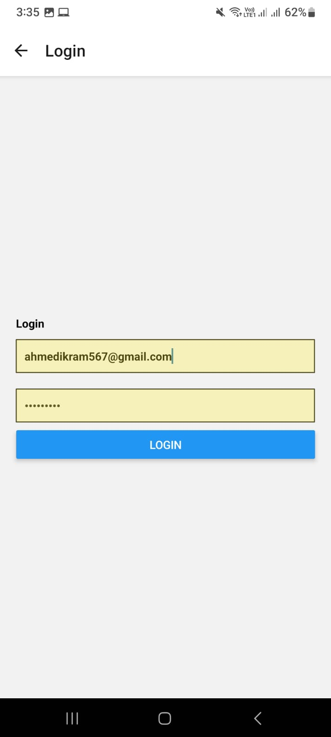
Third.js
import React from 'react';
import AsyncStorage from '@react-native-async-storage/async-storage';
import { useSelector } from 'react-redux';
import { View, Text, StyleSheet } from 'react-native';

export default function ThirdScreen() {
const location = useSelector((state) => state.user.location);

React.useEffect(() => {
const fetchStoredLocation = async () => {
const storedLocation = await AsyncStorage.getItem('userLocation');
console.log('Stored Location:', storedLocation);
};
fetchStoredLocation();
}, []);

return (
<View style={styles.container}>
<Text>Location: {JSON.stringify(location)}</Text>
</View>
);
}

const styles = StyleSheet.create({
container: { flex: 1, justifyContent: 'center', alignItems: 'center' },
});

